Register with Cloud Providers:   
AWS, AWS Educate, Microsoft Azure

**Objective:** Preparing for the upcoming practical works by getting register with Cloud Providers: AWS, AWS Educate, Microsoft Azure.

**Tasks:**

1. Sign up for AWS Free Tier account
2. Register with Amazon Educate
3. Register for Microsoft Azure Free Student Account

**Lab environment**:

* + Web browser

*Contents*

Preparation 3

Task 1: Sign up for AWS Free Tier account 3

Create a free tier AWS account 3

Set MFA for AWS account root user 3

Create an IAM admin user for your AWS account 4

Task 2: Register with Amazon Educate 7

Create a free tier AWS account 7

Signing in AWS Educate 8

Task 3: Register for Microsoft Azure Free Student Account 9

# Preparation

Use your UNIVERSITY EMAIL ACCOUNT to sign in for AWS and Microsoft Azure accounts. The trial accounts are free and offer a number of services free of charge for 1 month/year/forever.

Nevertheless, you might be asked to provide CREDIT CARD DETAILS to verify yourself.   
You will not be charged UNLESS explicitly select and agree to use a paid service or exceed the free limits (e.g. 750 hours of t2.micro Amazon EC2 instance per months). Thus, keep an eye on the resources used and do not exceed the specified limits, which are much more than it is necessary to complete the labs.

The best way to do this is to delete all created resources (e.g. VMs, disks, environments) after you complete the lab! The staff will not be responsible for your financial expenses caused by the above reasons!

Microsoft Azure will authenticate you via the university log in service using MFA. You will need to remember passwords for AWS and AWS Educate accounts.

# Task 1: Sign up for AWS Free Tier account

## **Create a free tier AWS account**

Create a free tier AWS account which will give you 12 months free access to almost all AWS resources following this guide: <https://aws.amazon.com/free/free-tier/>

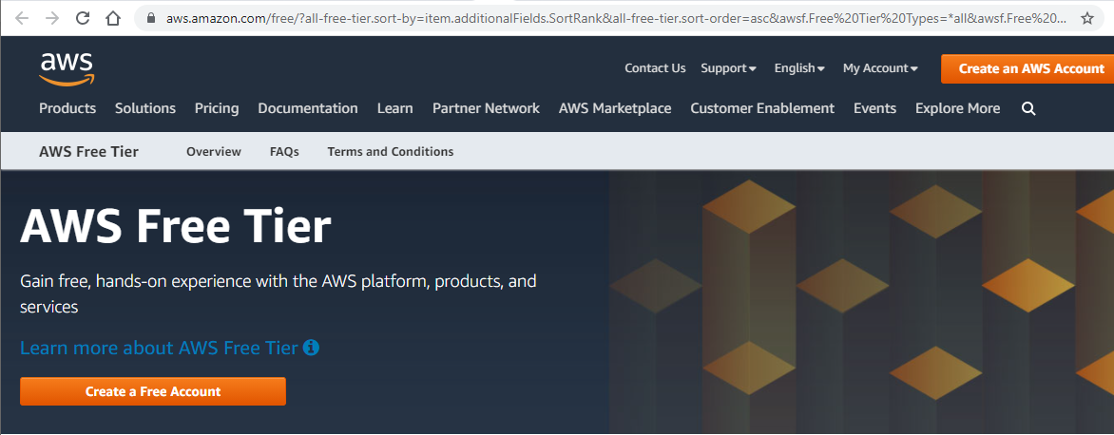

## **Set MFA for AWS account root user**

When you first create an Amazon Web Services (AWS) account, you begin with a single sign-in identity that has complete access to all AWS services and resources in the account. This identity is called the AWS account root user. You can sign in as the root user using the email address and password that you used to create the account. It is a good practice to set up MFA (e.g. using Microsoft Authenticator app) to secure your AWS root user account: <https://console.aws.amazon.com/iam/home#/security_credentials$mfa>

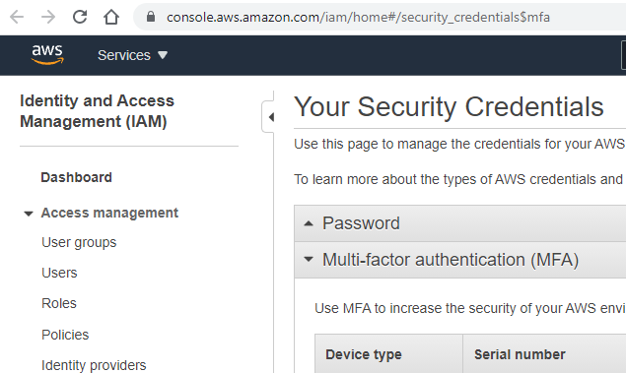

## **Create an IAM admin user for your AWS account**

It is strongly recommended that you do not use the root user for your everyday tasks, even the administrative ones. Instead, adhere to the [best practice of using the root user only to create your first IAM user](https://docs.aws.amazon.com/IAM/latest/UserGuide/best-practices.html#create-iam-users) (AWS Identity and Access Management (IAM) is a service which enables you to manage access to the rest AWS services and resources securely). Then securely lock away the root user credentials and use them to perform only a few account and service management tasks.

Follow this tutorial to set up an administrator for daily use: [Creating your first IAM admin user and user group](https://docs.aws.amazon.com/IAM/latest/UserGuide/getting-started_create-admin-group.html).

<https://console.aws.amazon.com/iamv2/home#/users>

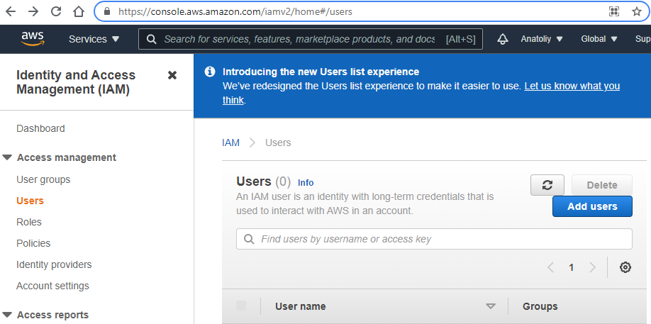

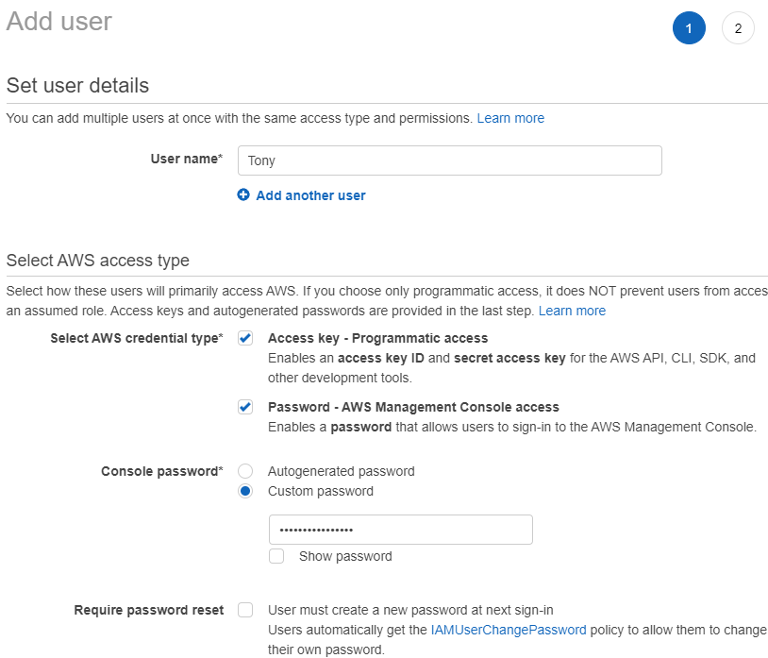

Follow the rest steps as instructed.

After you create an IAM user you can check sign-in credentials in the User’s ‘Summary’ tab of the Identity and Access Management (IAM):

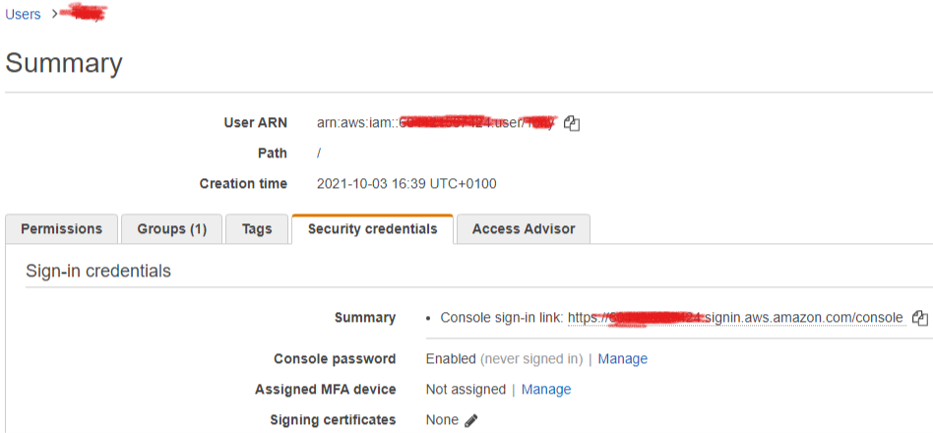

You can copy and use the link above to login to AWS management console not as a root user, but as an IAM admin user which is more secure.

You will also be able to see and download user credentials. This includes **aws_access_key_id** and **aws_secret_access_key** which are needed to deploy your applications on clouds (this is in addition to IAM user password).

!!! Download credentials as .csv file and save it (e.g. email to yourself) for the future use.

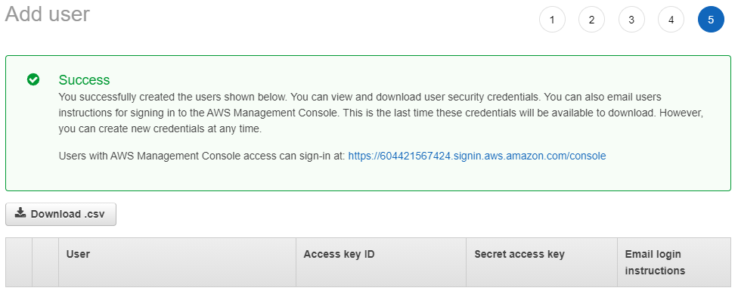

Sometimes you will need to configure the AWS browser which is a part of IDE (Visual Studio or Eclipse). With this purpose you will need to refer to your IAM user credentials (***aws_access_key_id***, ***aws_secret_access_key***) and copy/paste them into **%USER_HOME%/.aws/credentials** file on your PC/VM.

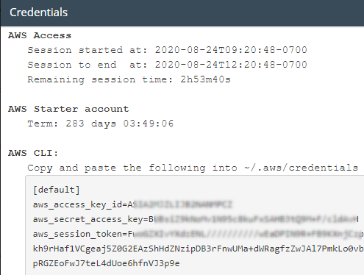

# Task 2: Register with Amazon Educate

## **Create a free tier AWS account**

AWS Educate is a grant program for educators, academic researchers and students.

The program augments Amazon's efforts to increase awareness of its public cloud services in the educational community. Qualified students can earn a series of Amazon Web Services (AWS) certifications, gaining important proficiencies as they enter the information technology (IT) workforce. AWS Educate

AWS used to grant students a $100 credit for an active AWS account. However, it has terminated access to AWS Console and other AWS resources via AWS Educate for students since 2021. So, to be able to complete labworks you need to create a free tier AWS account which will give you 12 months free access to almost all AWS resources (see Task 1).

Though, AWS Educate can still be used by students to get access to extra tutorials and standalone lab tacks offered by Amazon.

Create your own AWS educate account at <https://aws.amazon.com/education/awseducate/>.

Use your LBU email for registration and provide other requested details (your first name and surname, university name, etc.)**.** You will get 100 points credit to be spent within a year. Follow the instruction and check your email for confirmation. This can take a day or two.

Use ‘Join AWS Educate’; do not click on ‘Create an AWS Account’ in the top-right corner (this will create a commercial AWS account).

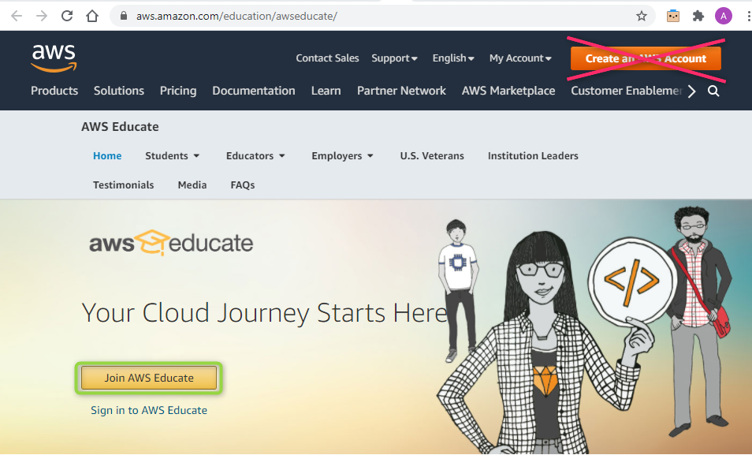

## **Signing in AWS Educate**

Sign into AWS Educate account at <https://www.awseducate.com/signin/>

Here you can select the lab you are interested in and follow the instructions to complete it, take a quiz and progress towards AWS certification as a part of your independent learning.

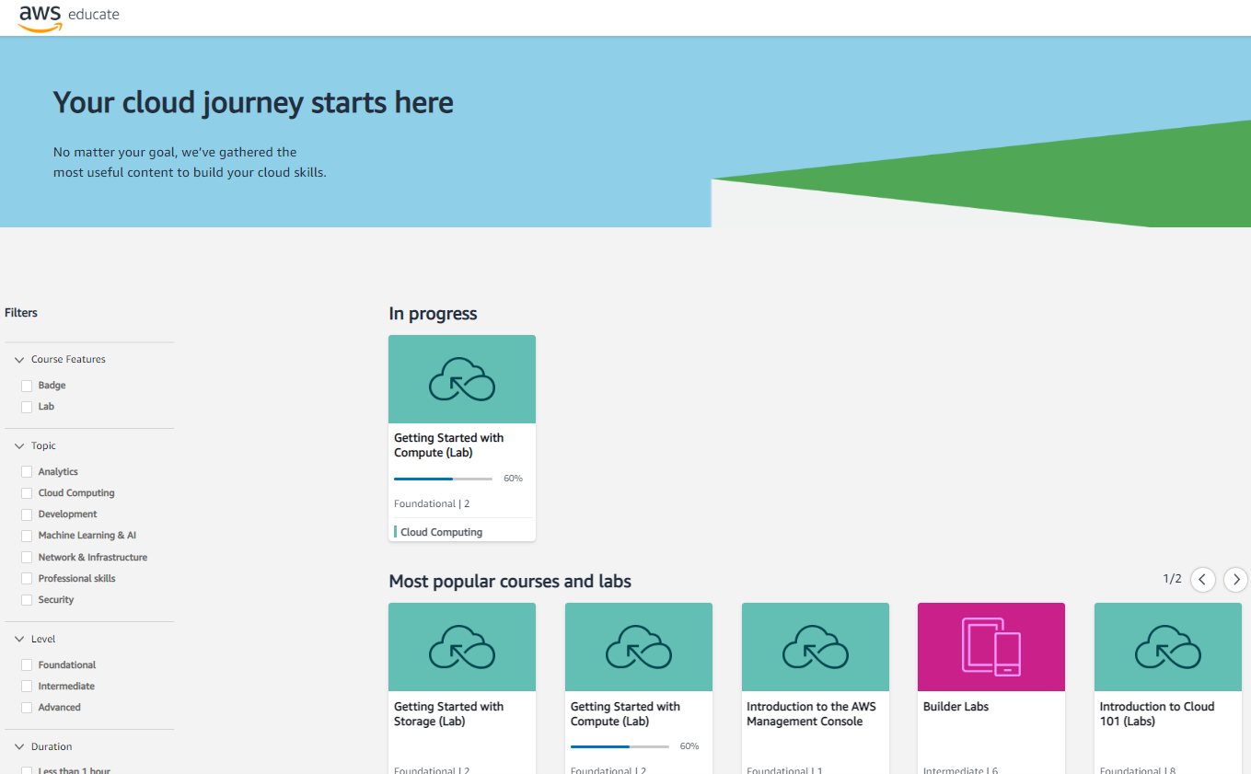

# Task 3: Register for Microsoft Azure Free Account

Register for Microsoft Azure Free Account using your university email at <https://azure.microsoft.com/en-gb/free/students/>. The trial account is free and offers a number of services free of charge for 1 year/forever. Take your time to explore the details.

